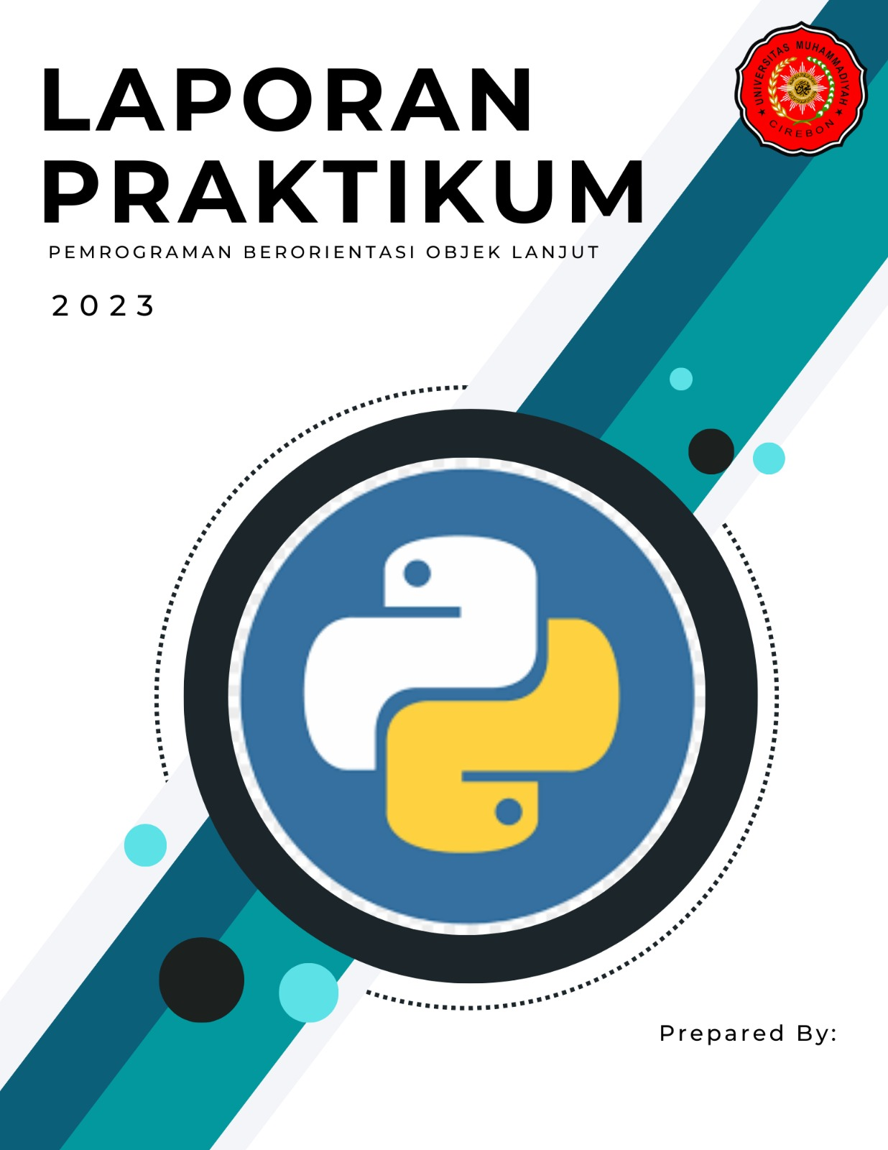

Nama : Rizky Resi Julian

NIM : 210511027

Kelas / Semester : R1(A) / 4

Laporan Praktikum 2 PBO 2

Tugas: Buatlah design tabel sebuah aplikasi database yang menerapkan Inheritance

HYBRID INHARITANCE

|  |
| --- |
| RuangKelas |
| kode_ruang |
| prodi |
| semester |

|  |
| --- |
| Mahasiswa |
| nim |
| nama |
| jk |
| kode_ruang |

Single inharitance kode_dosen

Single inharitance kode_dosen

|  |
| --- |
| MataKuliah |
| kodemk |
| namamk |
| kode_dosen |

|  |
| --- |
| Penilaian |
| nilai |
| kodemk |
| kode_dosen |
| nim |
| nama |

|  |
| --- |
| Dosen |
| kode_dosen |
| nama_dosen |

Multiple inharitance kode_dosen